MEDIA REVENUE WORKSHEETS
(E) ESPN = $1,000,000 (F) ox = $800,000 ( S) Sunshine = $250,000 (R) Raycom = $100,000
MY TEAM | WORKSHEET | TEAM: Florida Univ.
Opponent | Media  Source | Media Revenue | Media Revenue  Retained by Institution | Media Revenue Shared with Conference
- @Michigan | ESPN | $1,000,000 | $600,000 | $400,000
- Penn St | FOX | $800,000 | $480,000 | $320,000
- Indiana | N/A | $0 | $0 | $0
- @BGSU | N/A | $0 | $0 | $0
- Georgia | FOX | $800,000 | $480,000 | $320,000
- @Tennessee | ESPN | $1,000,000 | $600,000 | $400,000
- Vanderbilt | ESPN | $1,000,000 | $600,000 | $400,000
- @Kentucky | ESPN | $1,000,000 | $600,000 | $400,000
- @Missouri | ESPN | $1,000,000 | $600,000 | $400,000
- South Carolina | ESPN | $1,000,000 | $600,000 | $400,000
- Buffalo | Sunshine | $250,000 | $150,000 | $100,000
Bowl: Michigan | ESPN | $1,000,000 | $600,000 | $400,000
TOTAL |  | $8,850,000 | $5,310,000 | $3,540,000

Florida University
2016 Football Schedule
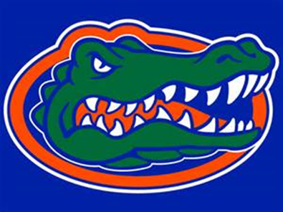
2016 Football Schedule
Date Opponent Location Time Media Rights
Sept. 3rd Michigan University Ann Arbor, MI 7pm ESPN
Sept. 10th Penn St University Gainesville, FL 7pm FOX
Sept. 17t Indiana University Gainesville, FL 7pm Local Networks
Sept. 24th Bowling Green St Bowling Green, OH 8pm Local Networks
Oct. 1st University of Georgia Gainesville, FL 3:30pm FOX
Oct. 8th University of Tennessee Knoxville, TN Noon ESPN
Oct. 15th Vanderbilt University Gainesville, FL Noon ESPN
Oct. 22nd University of Kentucky Lexington, KY 3:30pm ESPN
Oct. 29th Missouri University Columbia, MO 8pm ESPN
Nov. 5th University of South Carolina Gainesville, FL 8pm ESPN
Nov. 19th Buffalo University Gainesville, FL Noon Sunshine

*BYE weeks on November 12th & November 26th

Itinerary
*Buffalo Wild Wings Citrus Bowl, Orlando FL

Dec. 31st Activity
8:00 AM Eat breakfast on campus (Café)
9:00 AM Board the charter bus
10:30 AM Arrive to hotel in Orlando
12:00 PM Eat lunch at hotel (Catering)
1:00 PM Film study & team meeting
3:00 PM Leave for team trip to Disney World
6:00 PM Dinner back at the hotel (Catering)
9:00 PM Team Curfew
10:00 PM Lights out
Jan. 1st Activity
7:00 AM Hotel breakfast
8:00 AM Film study & team meeting
9:00 AM Leave for Stadium
10:00 AM Arrive and settle into locker room
11:00 AM Stretching & walkthroughs
12:00 PM Pregame talks and meetings
1:00 PM Game vs. Michigan
5:00 PM Go back to hotel/ free time
11:00 PM Curfew/ lights out
Jan. 2nd Activity
9:00 AM Wake up
9:30 AM Hotel breakfast
11:00 AM Load charter busses
11:30 AM Depart from Orlando
1:00 PM Arrive to campus in Gainesville

